**Program Title :** Smart Package Handling System

**Aim :**  Design a smart package handling system (TILT sensor and LED)

**Hardware Required:**

* Arduino Board
* TILT sensor
* LED
* resistor

**Circuit Diagram :**

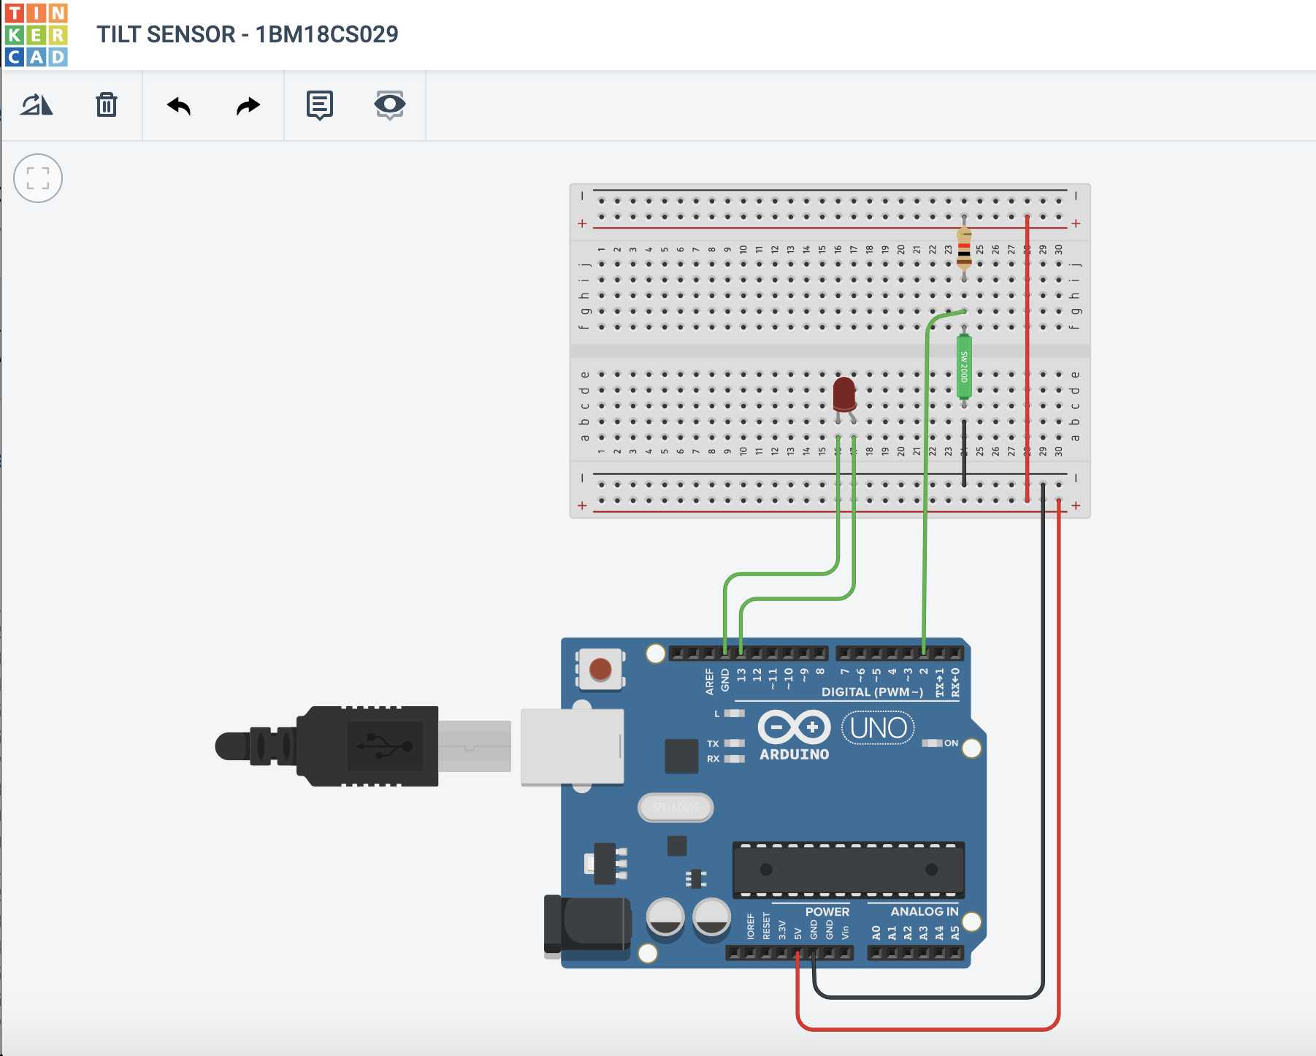

**Output/Working :**

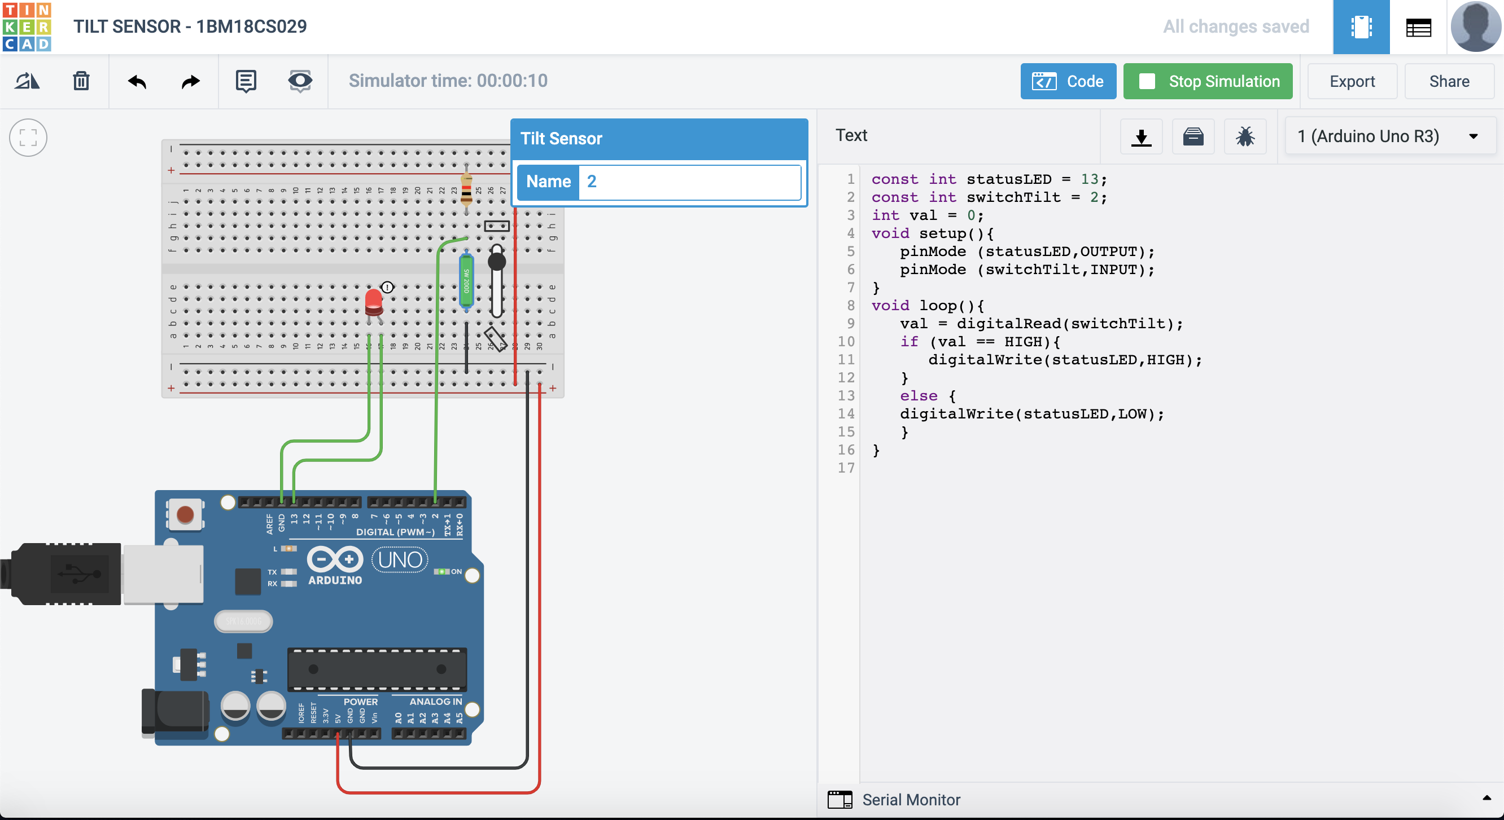

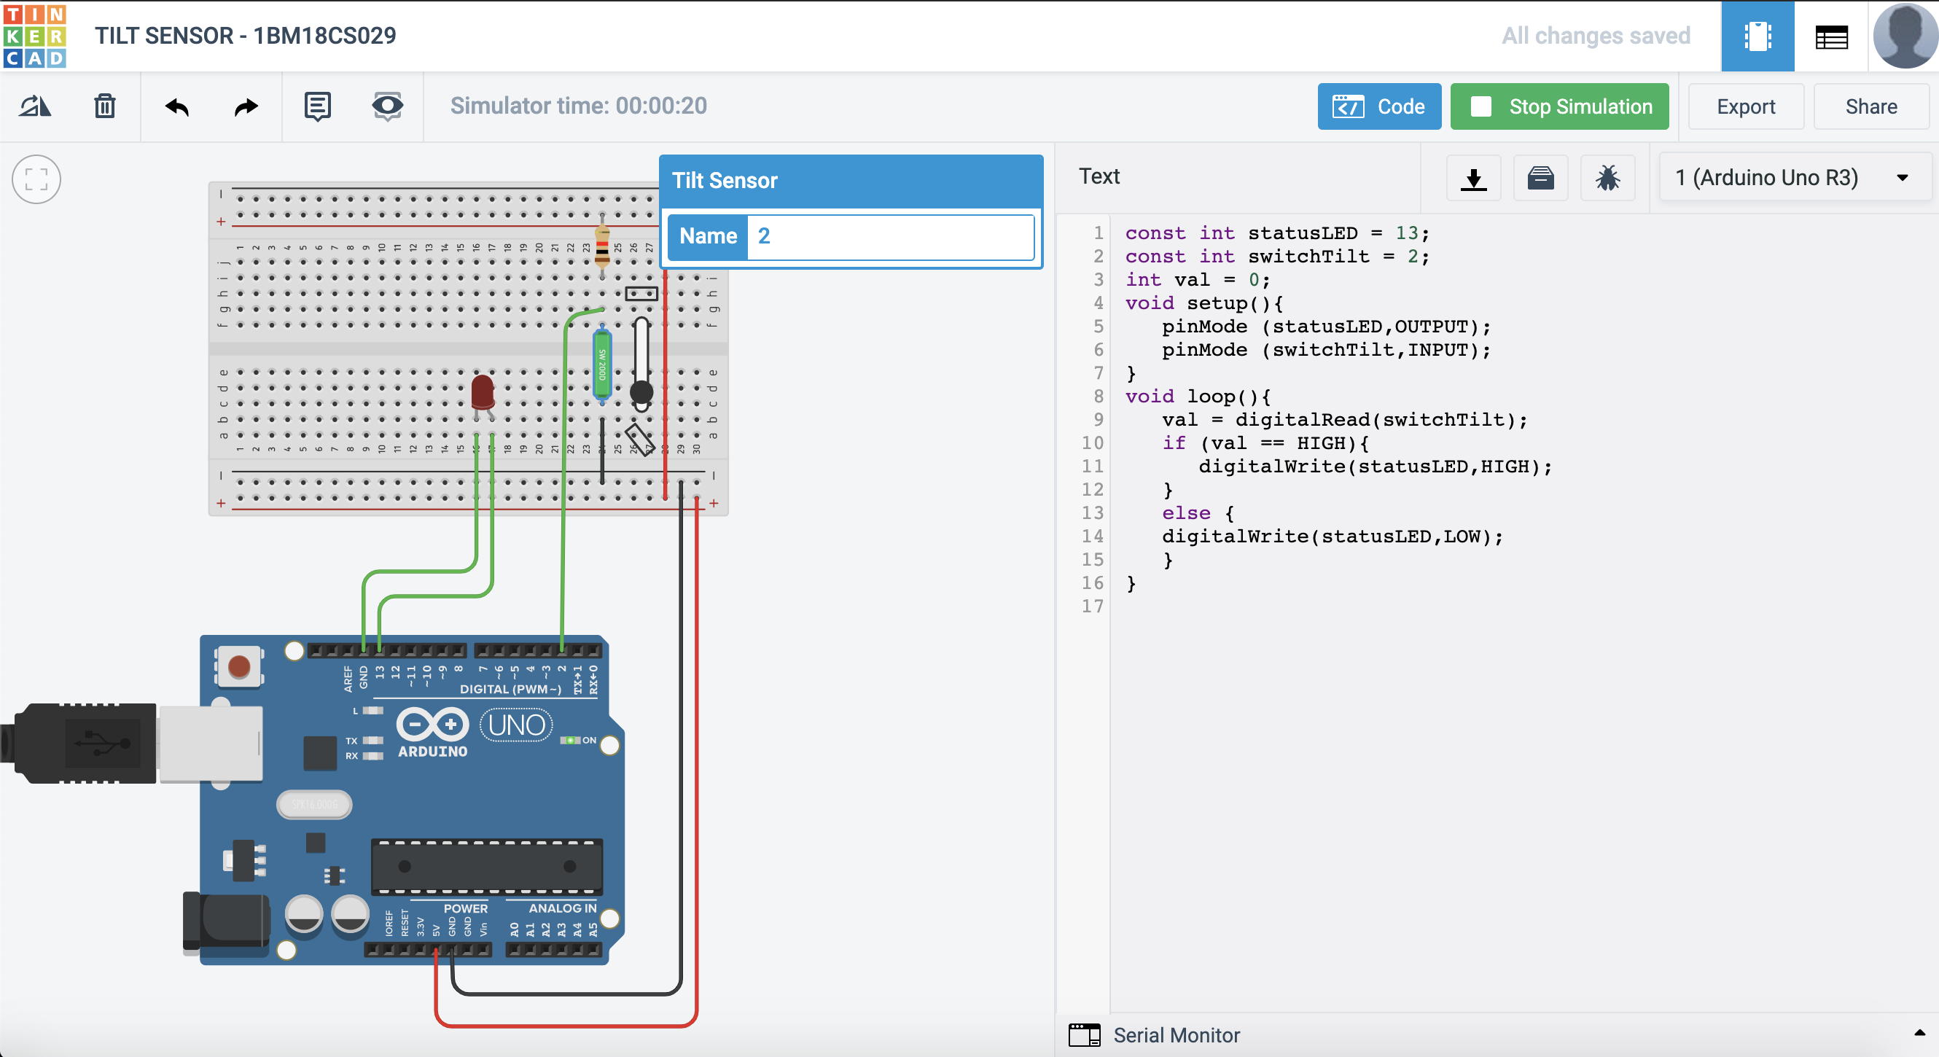

**Code:**



**Observation :**

The LED light fades as the TILT sensor tilts.